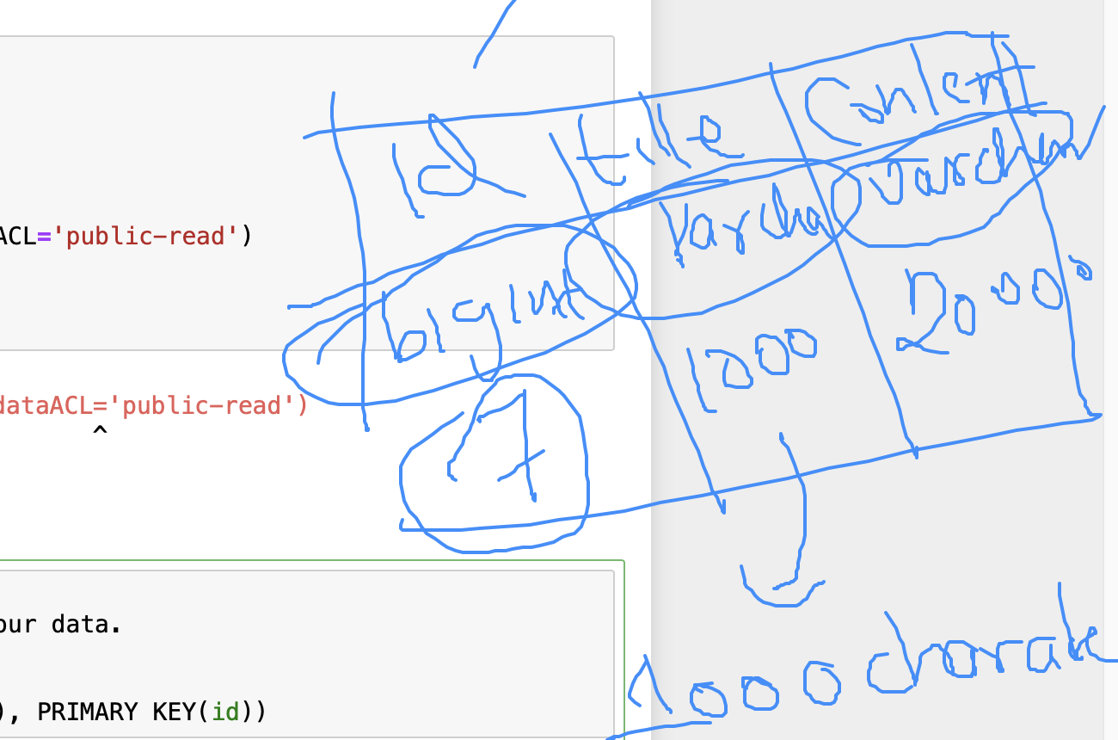

CREATE table scrap_pages(id bigint(7) not null auto_increment,

title varchar(200), content varchar(2000),

primary key(id))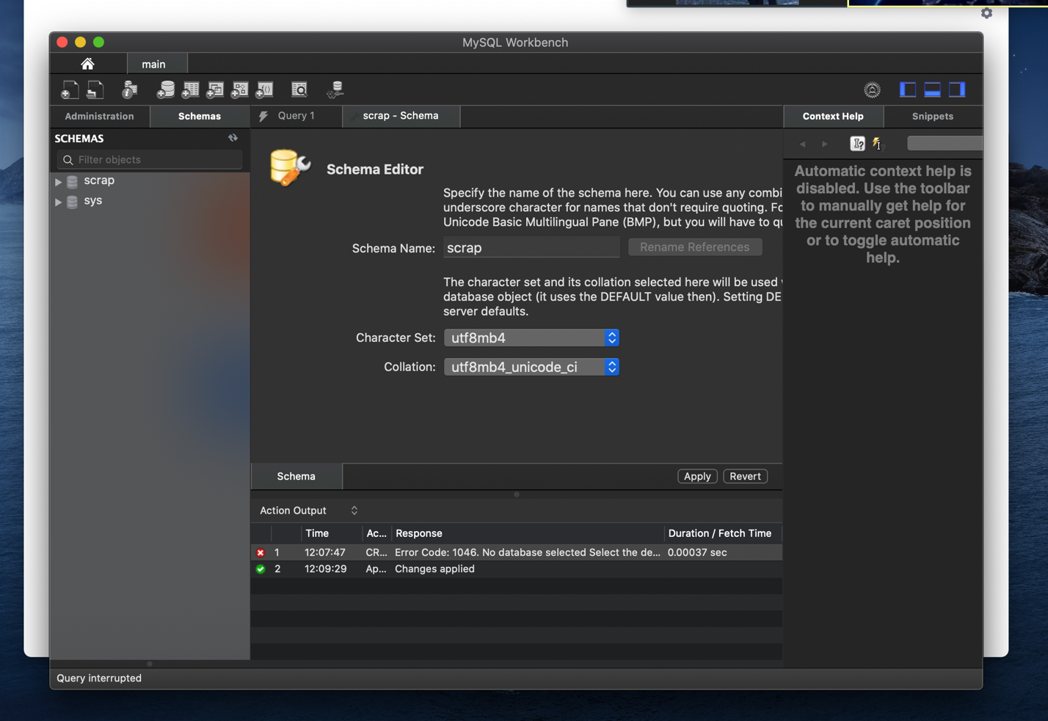

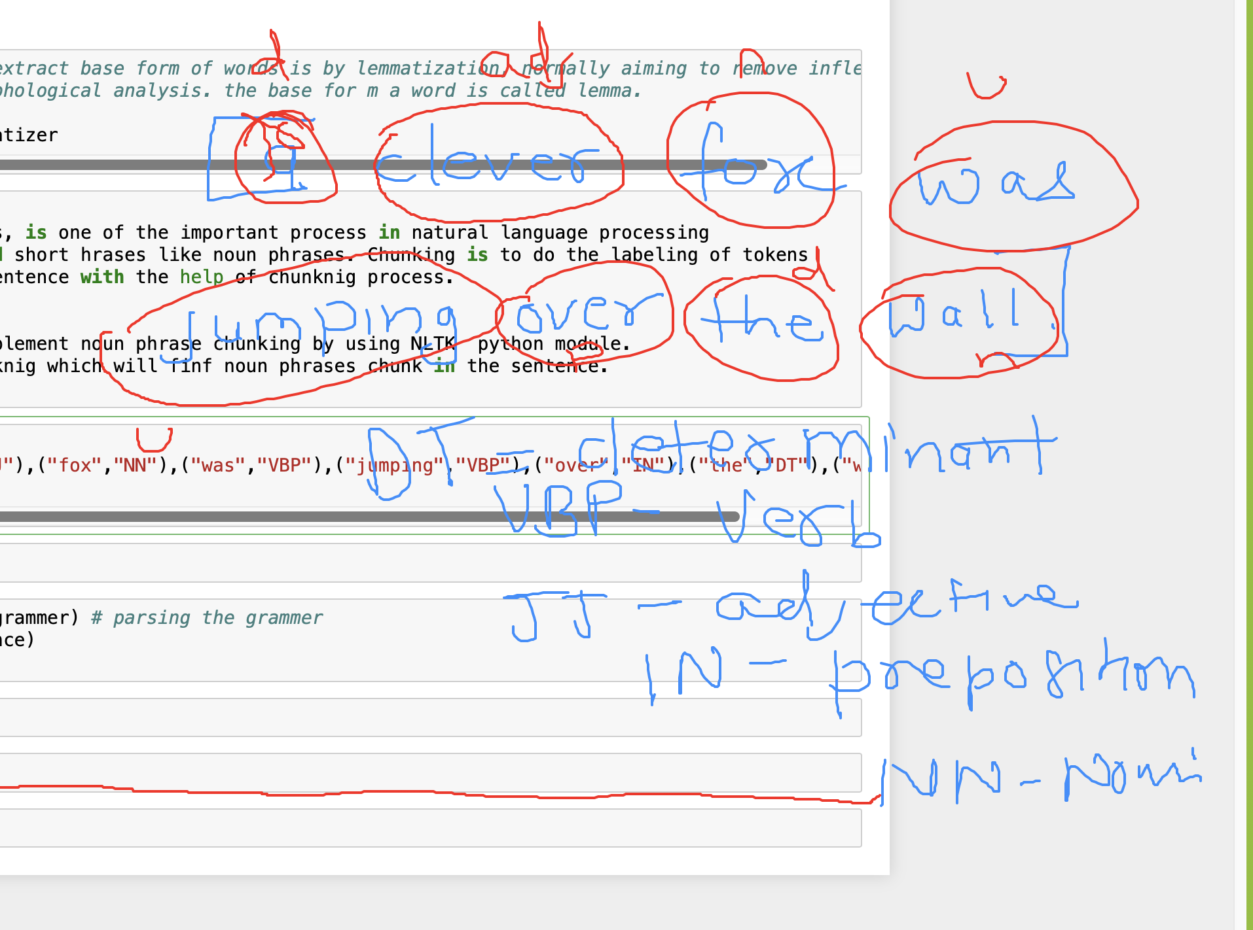

To get to the above.

**import** nltk

sentence=[("a","DT"),("clever","JJ"),("fox","NN"),("was","VBP"),("jumping","VBP"),("over","IN"),("the","DT"),("wall","NN")]

grammer = "NP:{<DT>?<JJ>*<NN>}"

parse_chunking=nltk.RegexpParser(grammer)

output=parse_chunking.parse(sentence)

output.draw()

then pythron.py file

then terminal

a clever fox.

python python.py  
jj means adjective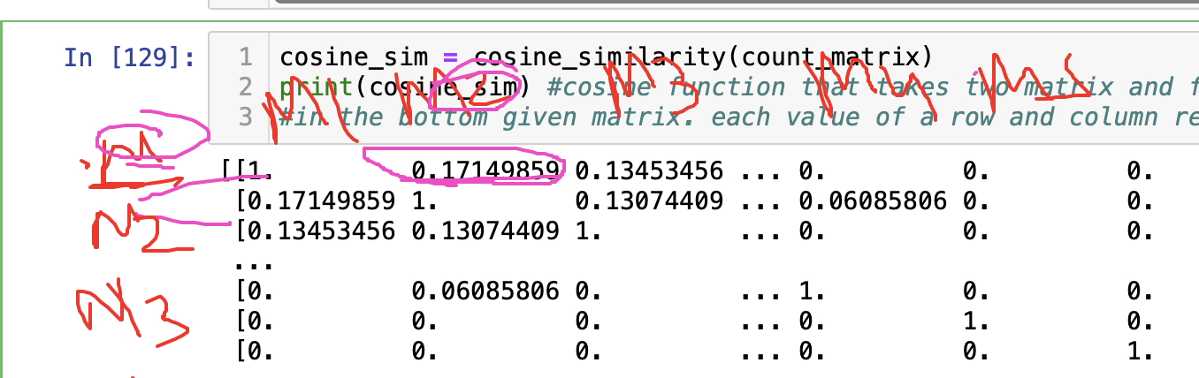, dt is determinant.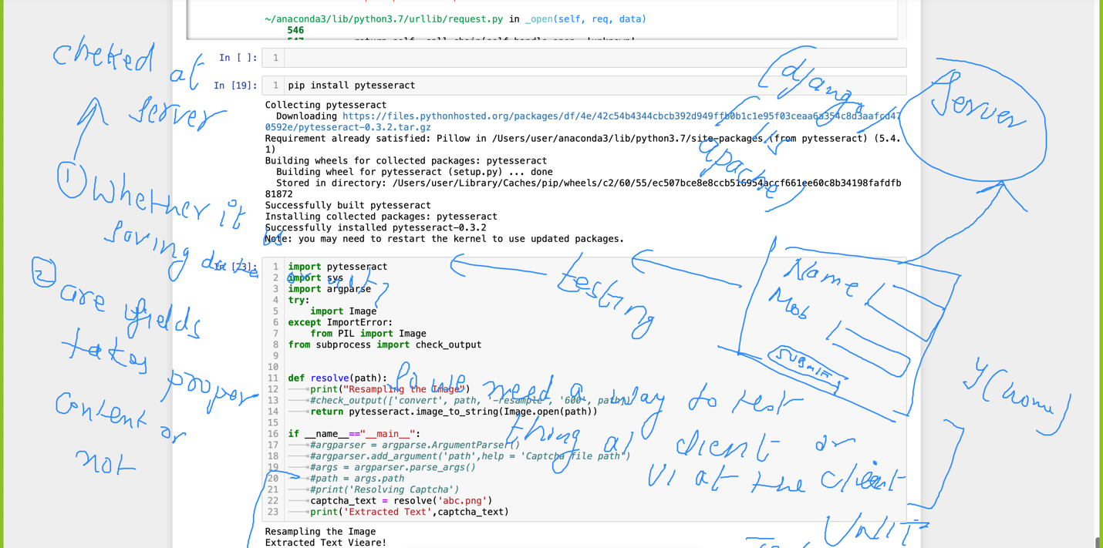 from selenium import webdriver

from webdriver_manager.chrome import ChromeDriverManager

driver = webdriver.Chrome(ChromeDriverManager().install())

driver.get('https://yelp.com')

screenshot=driver.save_screenshot('screenshot.png')

driver.quit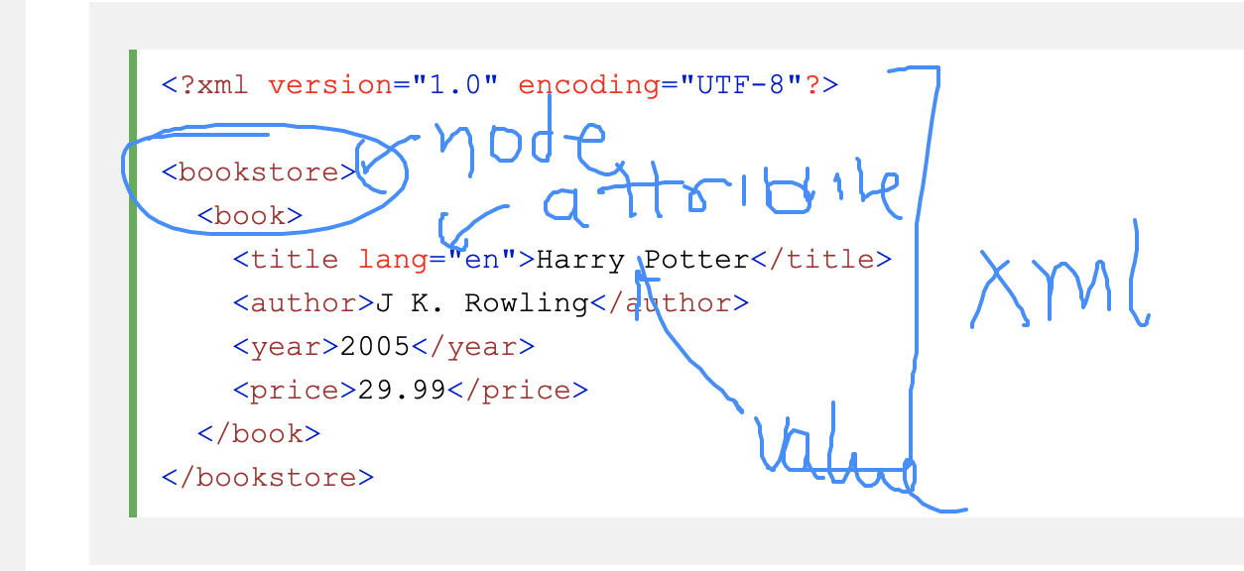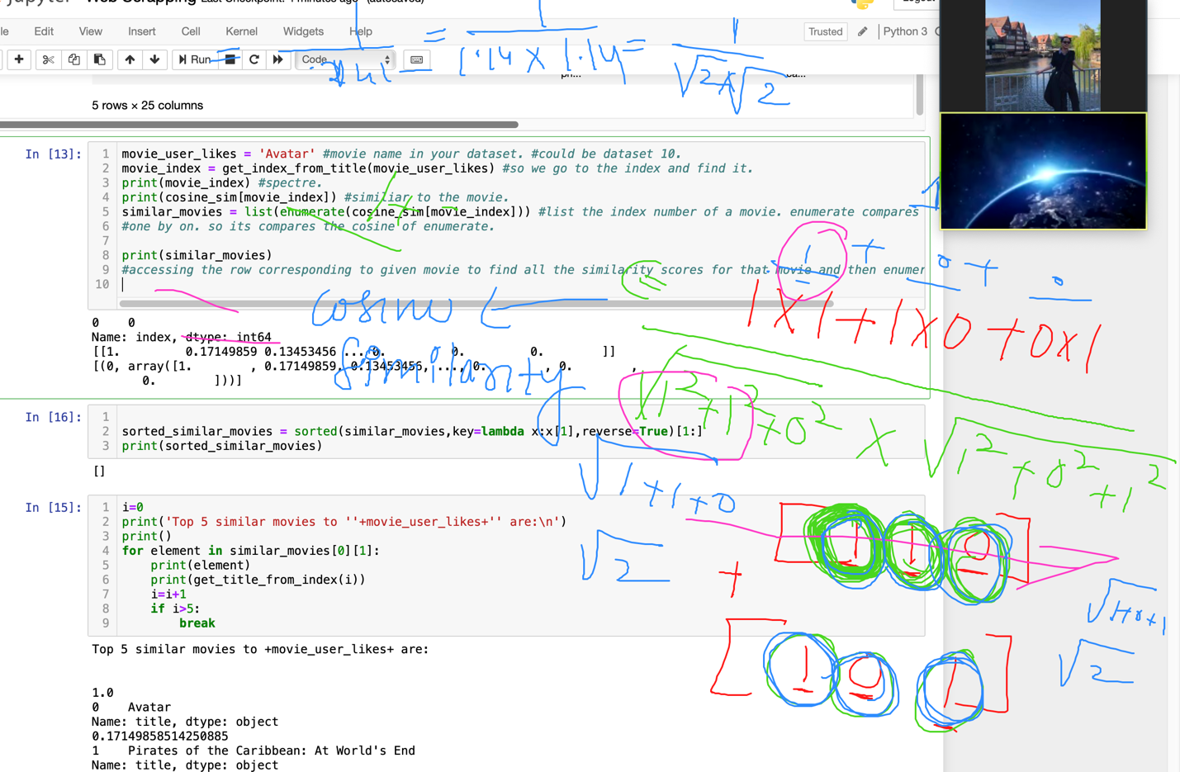

Unit test is testing technique in which we test small things independently. you test ui design, they test ux. web designer tests website and backend tests server. Integration

testing is process in which all the unit test cases will be tested combined (everything comes together)

deplay contunious deploy 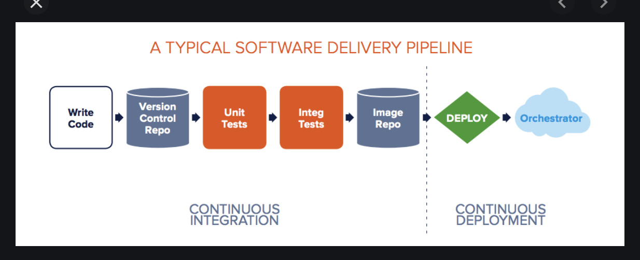

After the changes are maid to the product, the same has to be made available to usze..it should not wait for whole new version of software wjust form minor changes. In this scenario we use

concept of continuous deployment…We create an image of software and the image will be deployed

in docker this is called orchestration.